Transregional Collaborative Research Centre (TRR 51)

Ecology, Physiology and Molecular Biology of the Roseobacter clade:

Towards a Systems Biology Understanding of a
Globally Important Clade of Marine Bacteria

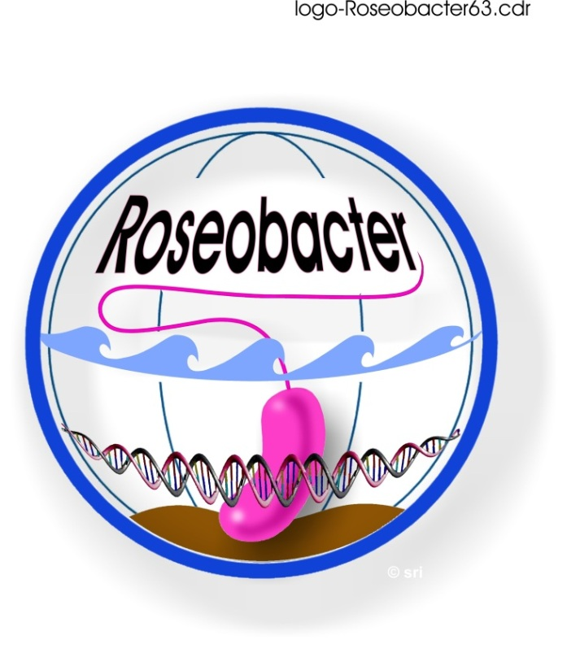

5th Status Seminar

Final Agenda

Date: 6 February 2012
Time: 10:45 h – 17:30 h
Venue: Helmholtz Center for Infection Research
Forum
Inhoffenstr 7
38124 Braunschweig
Organiser: M. Simon (ICBM, Oldenburg)

Topic: - Genomics of the Roseobacter clade
- Plenary assembly (Vollversammlung)
Contact: M. Simon (m.simon@icbm.de),

Program
Time | Subject | Speaker/Chair
10:45-11:00 | Welcome and Introduction | M. Simon
11:00-11:30 | A3: Metagenomics of North Sea bacterioplankton | Bernd Wemheuer
11:30-12:00 | A7: Population structure of Dinoroseobacter shibae and Phaeobacter gallaeciensis - implications for the ecology and evolution of the Roseobacter clade – Outline of the project | Heike Freese,  Jörg Overmann
12:00-12:30 | B3: Biosynthesis of tropodithietic acid by Phaeobacter gallaeciensis | Nelson Brock  Christopher Jungnickel
12:30-13:30 | Lunch
13:30-14:15 | Chemical ecology and natural products of marine inverte-brates – previous work and outline of a project proposal | Peter Schupp, ICBM
14:15-14:45 | C4: Fluxomics of selected marine bacteria and first results of a mesocosm experiment on metafluxomics | Arne Klingner
14:45-15:15 | Polarstern cruise from Cape Town to the German Antarctic Neumayer base, 3rd Dec. 2011 – 5th Jan. 2012 – report and first results | Helge Giebel,  John Vollmers
15:15-15:45 | Coffee break
15:45-16:15 | Plenary assembly  Business and financial affairs  Report of Research Training Group | Meinhard Simon and others
16:15-17:30 and beyond | Open for small discussion groups

