

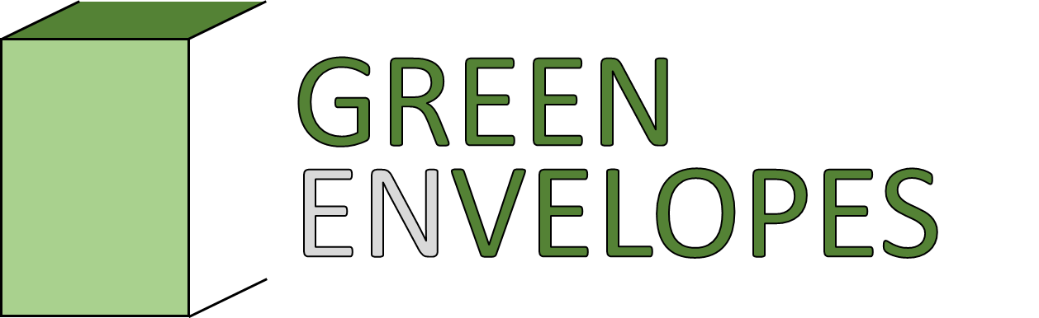
Ecosystem services of green building envelopes – observations and modelling
25-26 September 2026, online
- Please overwrite following existing text examples -
Title of presentation
Authors and affiliation
Stephan Weber, Technische Universität Braunschweig, s.weber@tu-braunschweig.de

Text (max 250 words)
The conference will focus on ecosystem processes and ecosystem services provided by green building envelopes, i.e. roofs and walls. We invite results from both observational and modelling studies. The conference will focus on ecosystem processes and ecosystem services provided by green building envelopes, i.e. roofs and walls. We invite results from both observational and modelling studies. The conference will focus on ecosystem processes and ecosystem services provided by green building envelopes, i.e. roofs and walls. We invite results from both observational and modelling studies. The conference will focus on ecosystem processes and ecosystem services provided by green building envelopes, i.e. roofs and walls. We invite results from both observational and modelling studies. The conference will focus on ecosystem processes and ecosystem services provided by green building envelopes, i.e. roofs and walls. We invite results from both observational and modelling studies.

References (if needed)
Konopka, J., Heusinger, J., Weber, S., 2021. Extensive Urban Green Roof Shows Consistent Annual Net Uptake of Carbon as Documented by 5 Years of Eddy-Covariance Flux Measurements. Journal of Geophysical Research: Biogeosciences 126, e2020JG005879. https://doi.org/10.1029/2020JG005879

